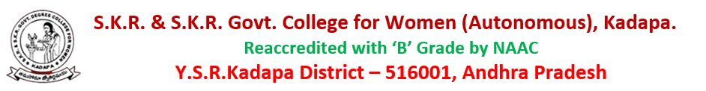
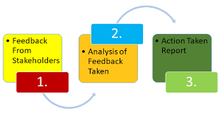
1.4.1 - Structured feedback and review of the syllabus (semester-wise / year-wise) is obtained from 1) Students 2) Teachers 3) Employers and 4) Alumni:
stakeholders’ feedback report
The college collects feedback on curricular aspects from various stakeholders
1) Students
2) Teachers
3) Employer
4) Alumni

The CBCS/APSCHE pattern of syllabus has been introduced in SKR & SKR Government College for Women(A), Kadapa. in the academic year 2020- 21. The college has collected the feedback on the CBCS/APSCHE curriculum from the following stakeholders to get an idea about the response of the stakeholders regarding the relevance, utility, feasibility and applicability of the system in the current academic scenario.
Both quantitative and qualitative data were collected on the syllabus. Stakeholder wise feedback analysis is given below.
This is further helping us to improvise our curriculum as per the expectations of the stakeholders. In the Academic council/BOS meeting rectified the gaps and made necessary changes for the next BOS meeting to increase the standards of the curriculum in various courses if necessary. Introduction of new courses on the current needs of the global competence to strength the students to stay infret of any global challenges and also feed them to pursue higher education in their own interested field.

FEEDBACK ANALYSIS OF STAKEHOLDERS AND ACTION TAKEN REPORT
(2021 -2022)
The instruction considers the curriculum as the heart of education and finds it important to assess the feed backs from its stakeholders namely Students, Teachers, Employer and Alumni. After receiving the feed backs in the structured format, the IQAC analyses them and report is submitted to the staff council members.
Online comments on the curriculum and associated topics have been gathered in IQAC at www.skrgdcwakdp.edu.in. For each group—students, teachers, alumni, and employer experts—separate feedback forms have been developed. This tab is available around-the-clock, and analysis is done for 2021-2022.
- Students Feedback on Curriculum (2021-22):
The feedback on curriculum from students were obtained after the end of each academic session. Students opinion on syllabus were measured in a four-point scale (1- Excellent-2- Very Good -3-Good-4- Satisfactory) For analysis, 238 students from 19 UG programs and 2 PG programs provided feedback on the curriculum. The data collected has been analyses and the results given below.
Table 1: Students feedback and action taken report Based on the student’s feedback, appropriate changes were made as is notified in the following table.

Student feedback on Curriculum -UG 2021-22
Curriculum Feedback Analysis Report
Students’ feedback
Table 1: Percentage distribution of responses by categories

1 | The Syllabus is suitable to the programme, need bases and updated
2 | They syllabus has good balance between theory and application
3 | The syllabus generates interest in the subject area
4 | The syllabus is relevant to professional development and preparation for job
5 | They syllabus covers recent trends and developments
6 | The syllabus prepares and motivates me to pursuer higher education/research.

Curriculum Feedback Analysis Report
QUESTIONS | Q1 | Q2 | Q3 | Q4 | Q5 | Q6
EXCELLENT | 58.8% | 39.9% | 46.6% | 43.7% | 50.8% | 48.3%
V.GOOD | 29.4% | 43.3% | 34.5% | 41.2% | 13.2% | 1.2%
GOOD | 11.3% | 15.5% | 16.8% | 33.2% | 15.1% | -
SATISFACTRY | - | 1.3% | 2.1% | 38.7% | 12.2% | 8%

Internal quality assurance cell
Feedback Analysis Report-2021-2022
Student feedback
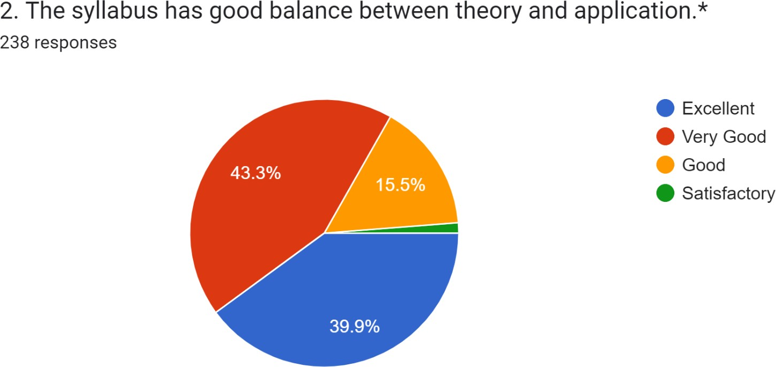
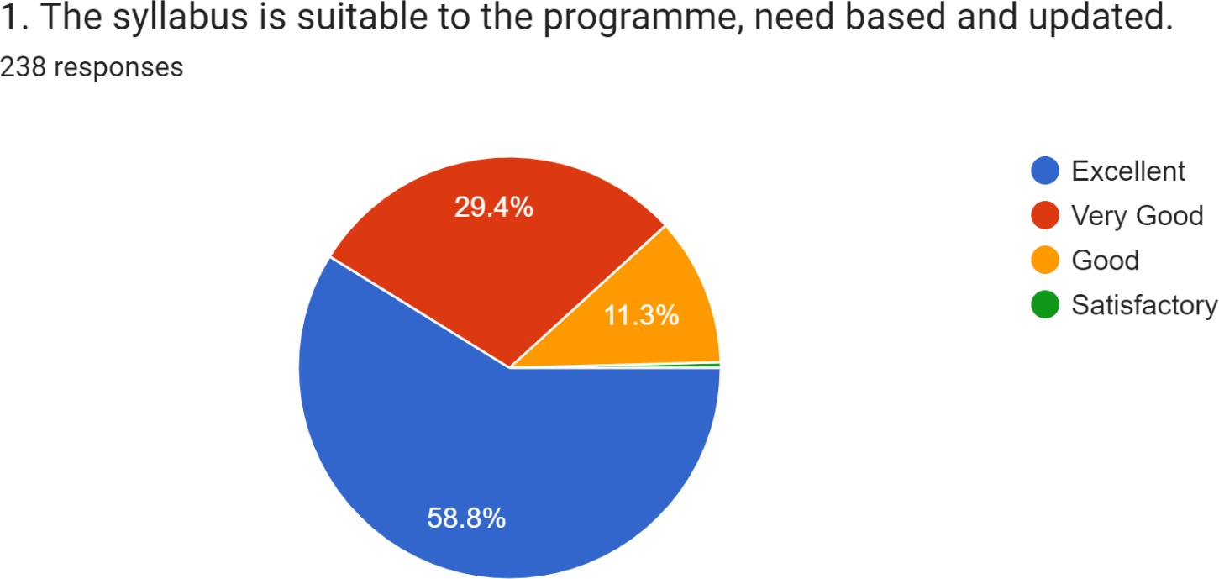
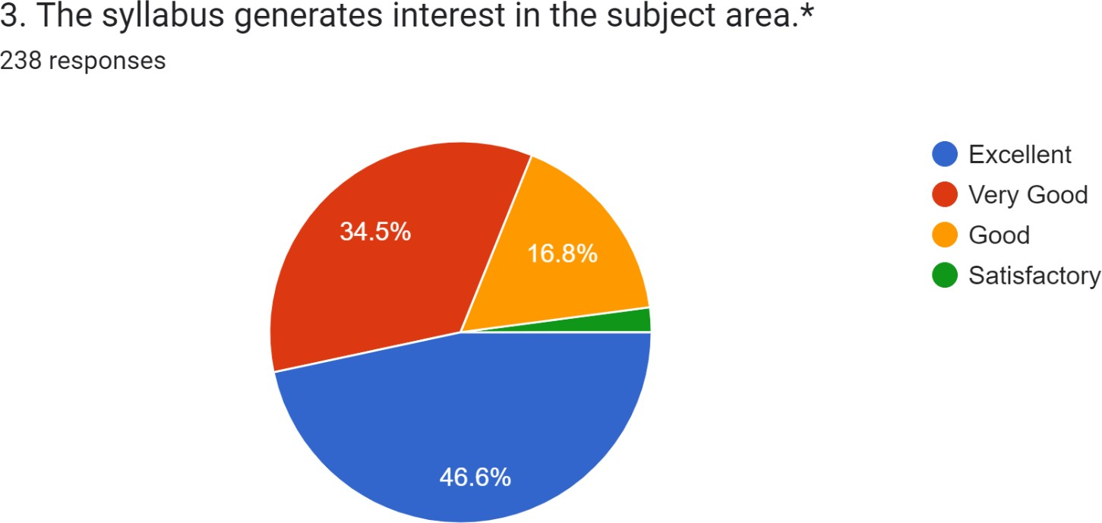
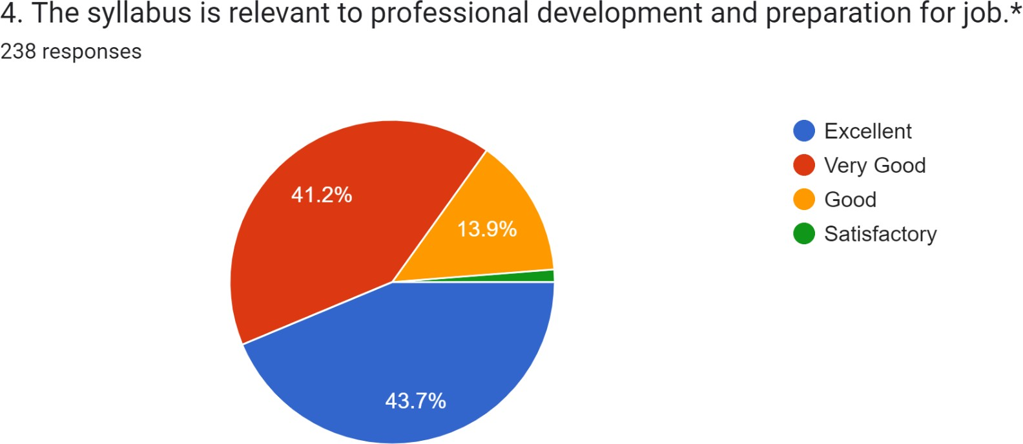
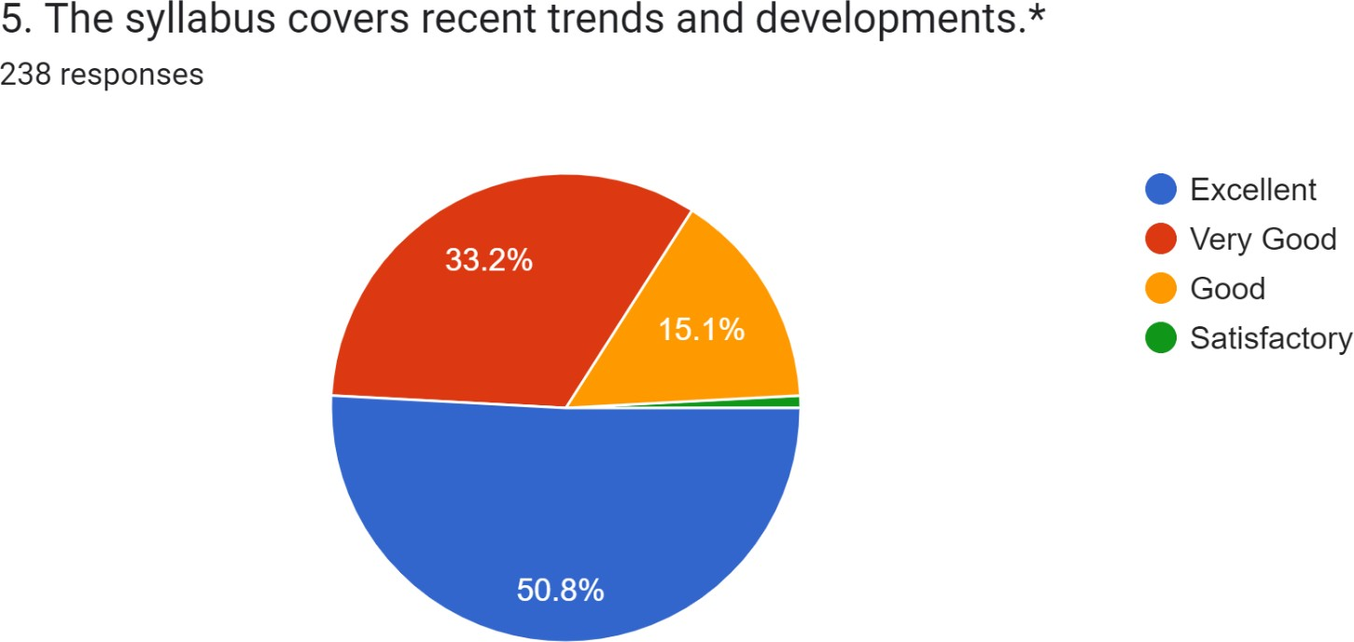

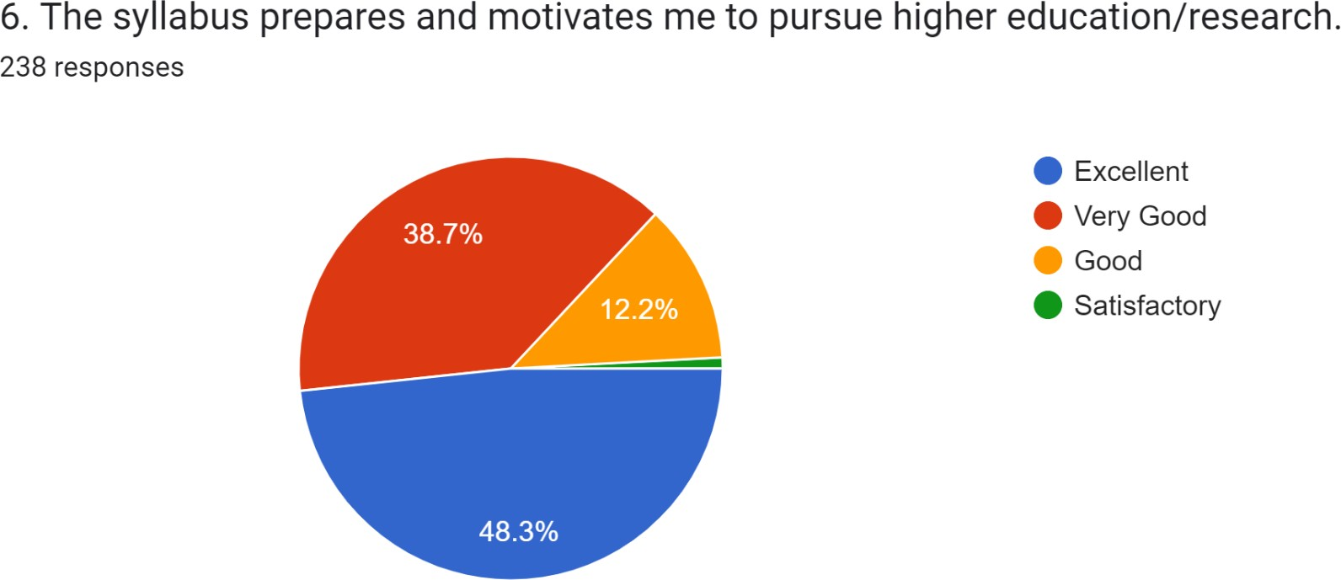

ACTION TAKEN REPORTS ON STUDENT’S FEEDBACK ON CURRICULUM
Action Taken Report 2021-22
Feedback Analyses report result is The majority of pupils have Excellent opinions about how curriculum development is done. so the departments has not taken any action at this moment regarding the syllabus. But the faculty members have decided unanimously that additional/alteration of syllabus must be carried out in regular intervals.
- New Programmes Started BA (HPU), 2021-22 and BBA will be stared 2022-2023.
- Certificate Courses organized
- Field trips, field projects (CSP) to be down
- Through Compulsory internship provide the students.

Internal quality assurance cell
Feedback Analysis Report-2021-2022

II-Teacher’s Feedback Form-44
The feedback on curriculum from Teacher were obtained after the end of each academic
2021-22 session. Six curriculum-related questions make up the format of the Teachers questionnaire. Teacher’s opinion on syllabus were measured in a four -point scale (1- Excellent-2- Very Good -3-Good-4- Satisfactory). 44 Teacher from 19 UG programs and 2 PG programs provided feedback on the curriculum.
Table 2: Percentage distribution of responses by categories:

Teachers feedback
Table 2: Percentage distribution of responses by categories

Q.NO | Description
1 | The Syllabus is need based, updated and has good balance between theory and application
2 | They syllabus provides comprehensive knowledge and perspective in the subject area
3 | The assessment and evaluation system objectively measure the course outcomes (Cos)and Program Specific Outcomes (PSOS)
4 | The college has enough relevant resources which are updated regularly for teaching learning purposes
5 | Course content has enough scope for development of analytical, logical, technical and creative skills to the students
6 | The syllabus has prospects for competitive exams/higher education/employability

Feed Back Analysis Report

QUESTIONS | Q1 | Q2 | Q3 | Q4 | Q5 | Q6
EXCELLENT | 88.6% | 77.3% | 70.5% | 68.2% | 72.7% | 68.2%
V.GOOD | 11.4% | 22.7% | 29.5% | 29.5% | 27.3% | 31.8%
GOOD | -- | -- | -- | 3.3% | -- | --
SATISFACTRY | -- | -- | -- | -- | -- | --
Feedback Analysis Report-2021-2022

II-Teacher’s Feedback on Curriculum-44

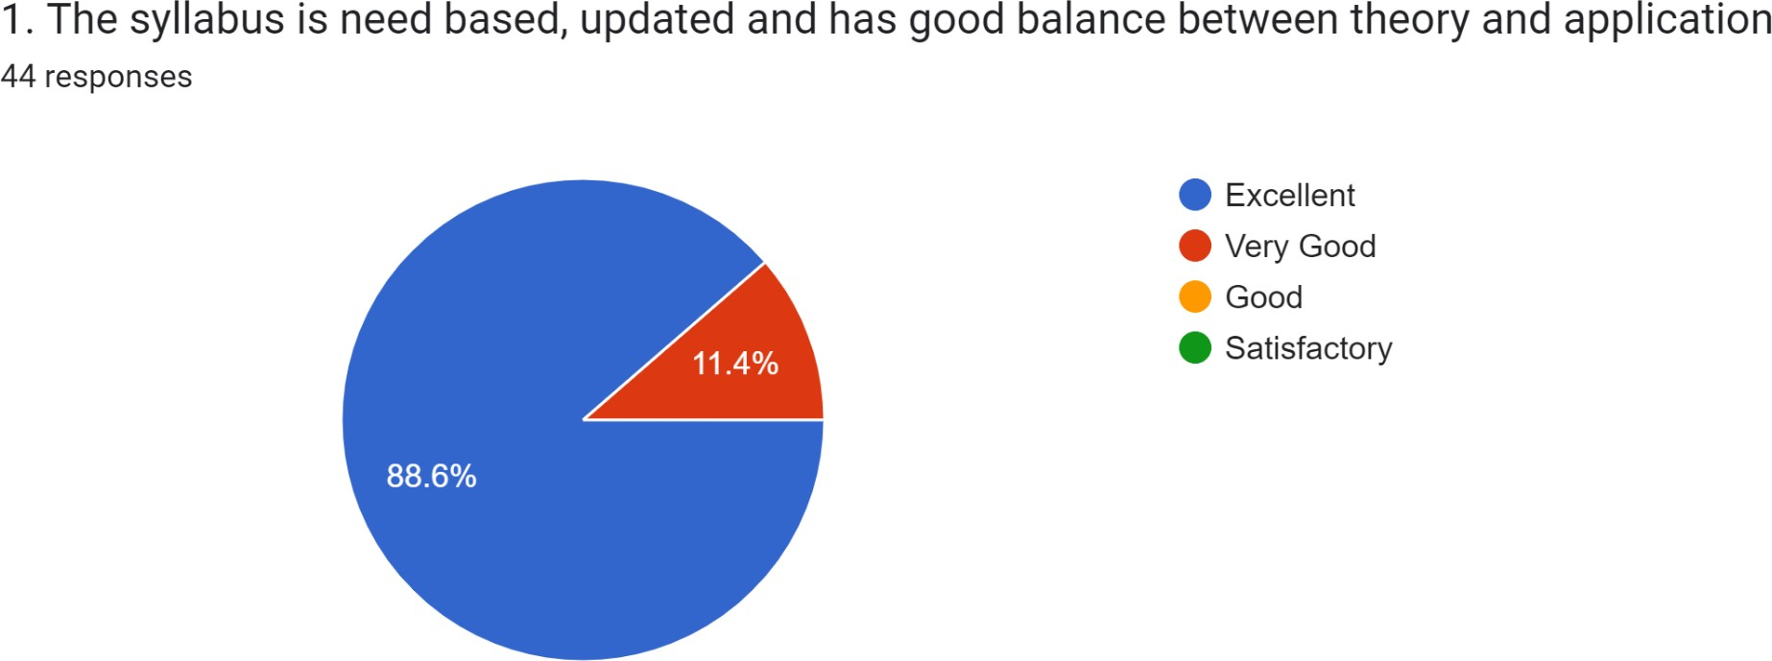

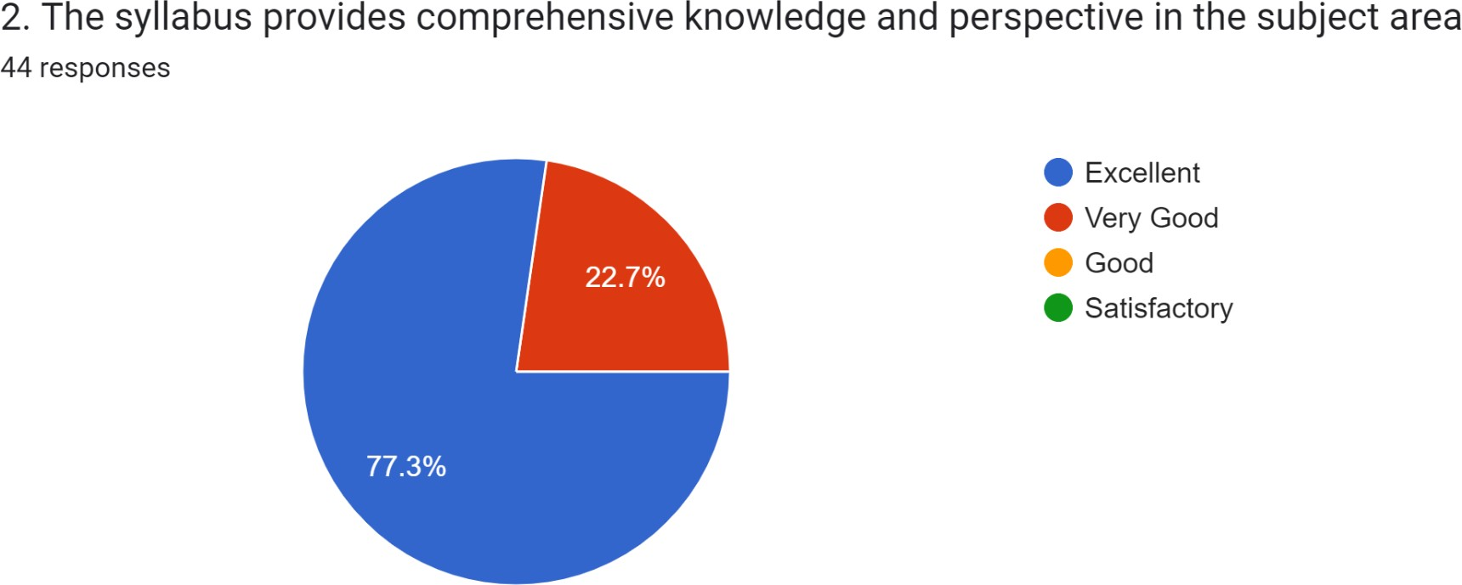

Internal quality assurance cell
Feedback Analysis Report-2021-2022

II-Teacher’s Feedback on Curriculum-44

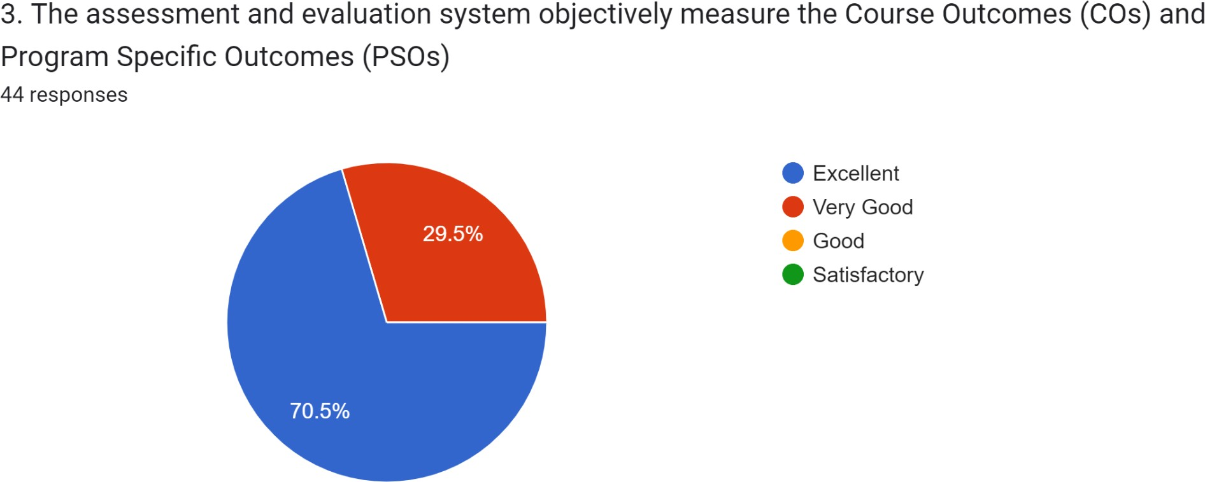

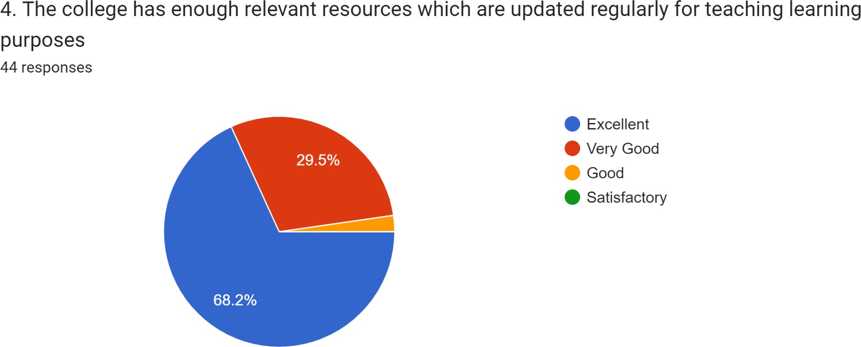

Internal quality assurance cell
Feedback Analysis Report-2021-2022

II-Teacher’s Feedback on Curriculum-44

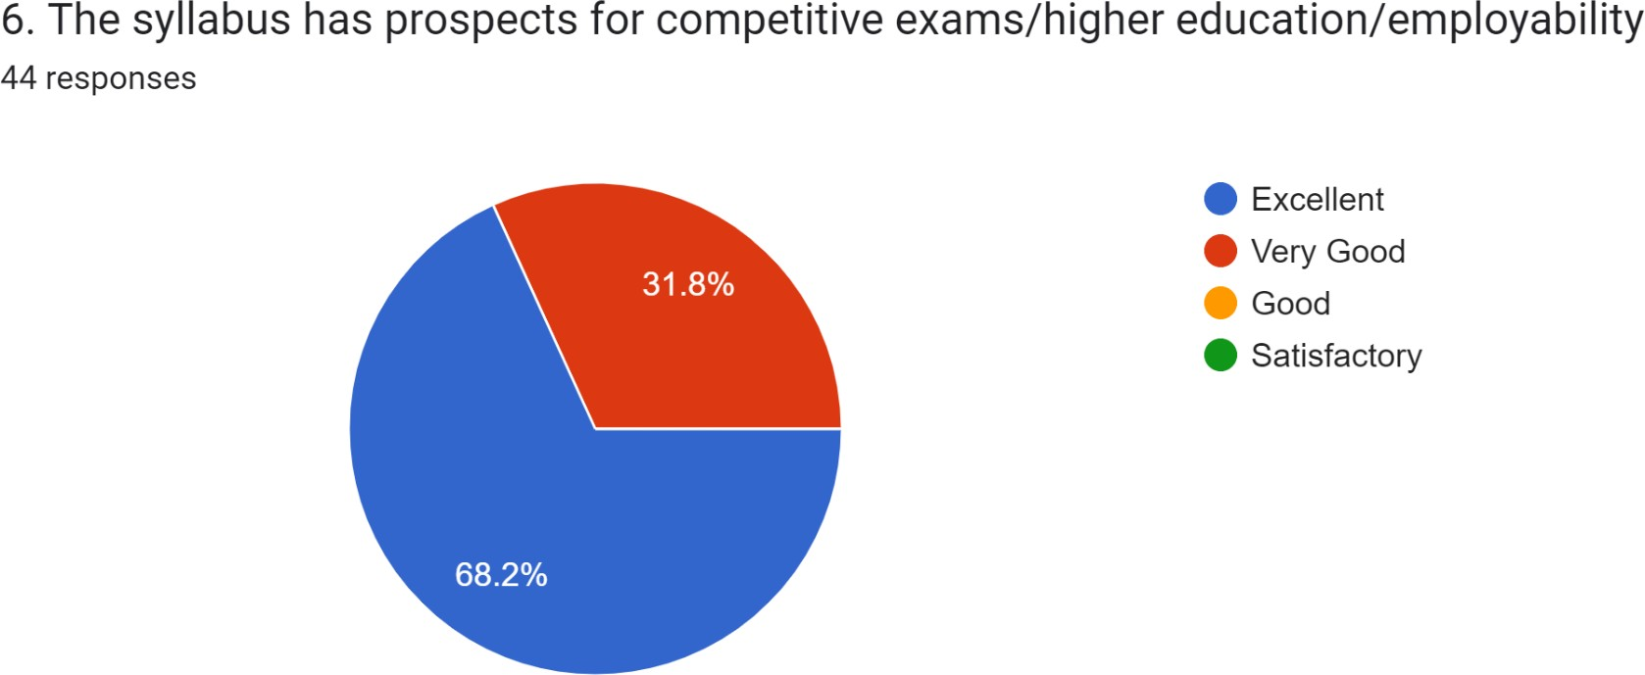
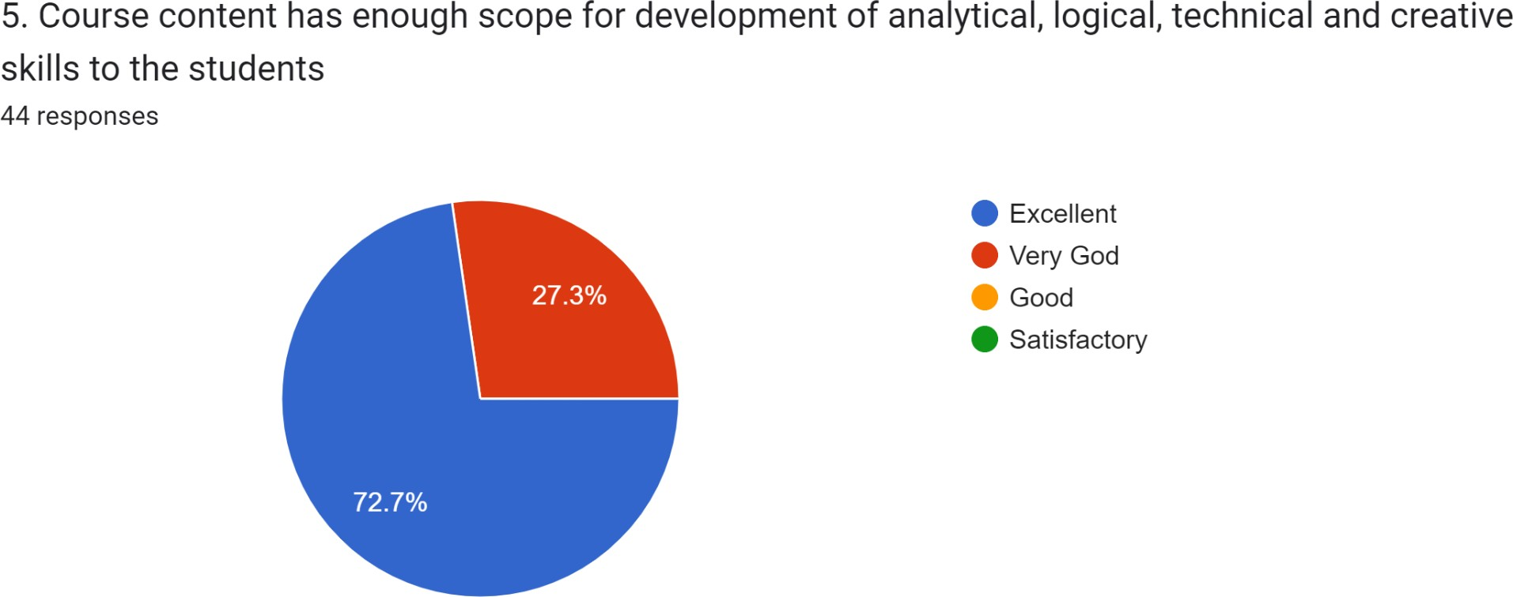

ACTION TAKEN REPORTS ON Teachers’ FEEDBACK ON CURRICULUM
Action Taken Report 2021-22
The majority of teachers had very positive thoughts about how curriculum development is carried out, according to feedback analysis report results. Consequently, the departments have not yet taken any action in relation to the syllabus. But the faculty has unanimously agreed that adding to or changing the syllabus must be done periodically. New Programmes Started 1.BA (HPU), 2021-22 and BBA will be stared 2022-2023.
2.Certificate Courses organized
3.Field trips, field projects (CSP) to be down
4. Through Compulsory internship provide the students.
5. Coaching for all competitive exam and PG entrance have provide every year

Internal quality assurance cell
Feedback Analysis Report-2021-2022

III- Alumni Feedback- 42

The feedback on curriculum from Alumni were obtained after the end of each academic
2021-22 session. Eight curriculum-related questions make up the format of the Alumni questionnaire. Students opinion on syllabus were measured in a four -point scale (1- Excellent-2- Very Good -3-Good-4- Satisfactory). 42 Alumni from 19 UG programs and 2 PG programs provided feedback on the curriculum

Feed Back Analysis Report
S.No | Description
1 | Syllabus was a sufficiently updated syllabus
2 | The Couse content delivery was interesting
3 | The course curriculum was intellectually
4 | Sufficient number of prescribed books is available in the Library
5 | The course curriculum was fulfilling my expectations
6 | Th syllabus created an interest in me pursue PG/Research studies
7 | They syllabus and dynamics at S.K.R & S.K.R GDC(A) College has helped me in my career.
8 | Specify the technologies/topics to be added to make syllabus/curriculum more updated.

QUESTIONS | Q1 | Q2 | Q3 | Q4 | Q5 | Q6 | Q7 | Q8
EXCELLENT | 54.8% | 40.5% | 40.5% | 50% | 45.2% | 42.9% | 43.9% | 33.3%
V.GOOD | 35.7% | 38.1% | 28.6% | 19% | 26.2 | 42.9% | 34.1% | 35.7%
GOOD | 9.5% | 14.3% | 28.6% | 19% | 19% | 9.5% | 19.5% | 26.%
SATISFACTRY |  | 7.1% | 2.3% | 11.9% | 9.5 | 5.7% | 2.5% | 4.8%

Internal quality assurance cell
Feedback Analysis Report-2021-2022
Alumni Feedback Report

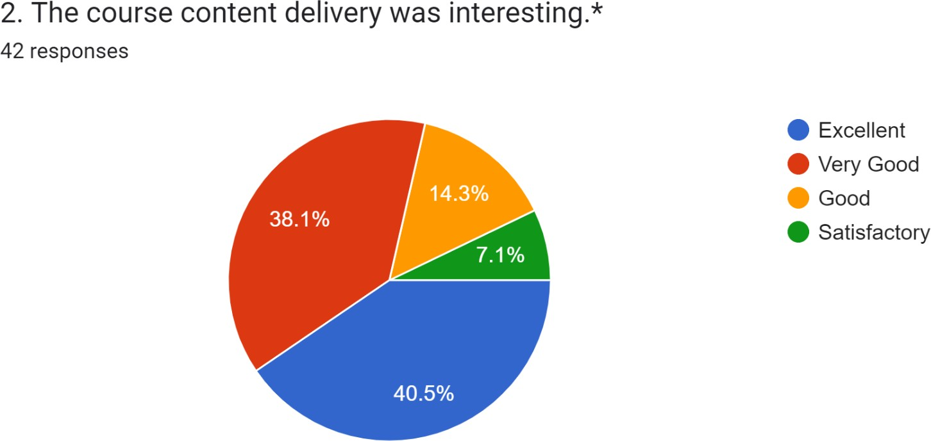
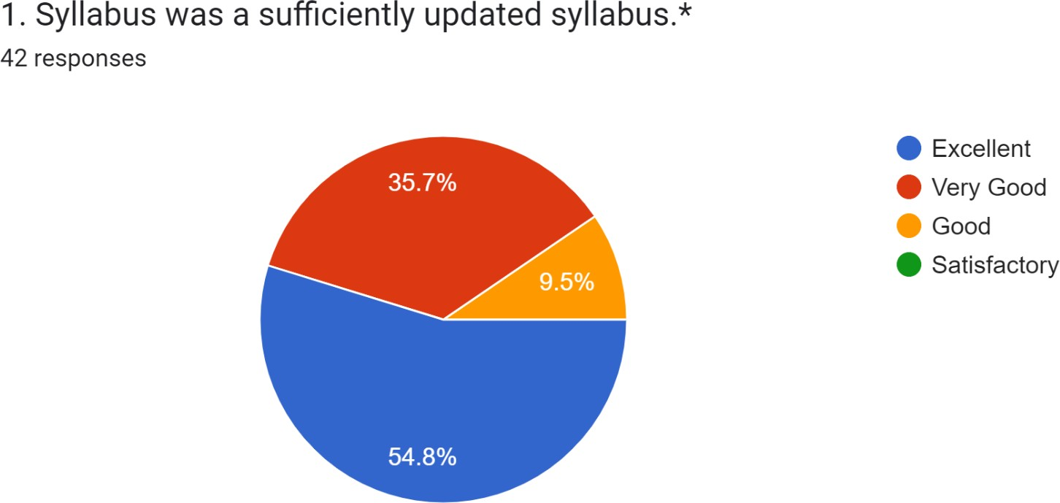
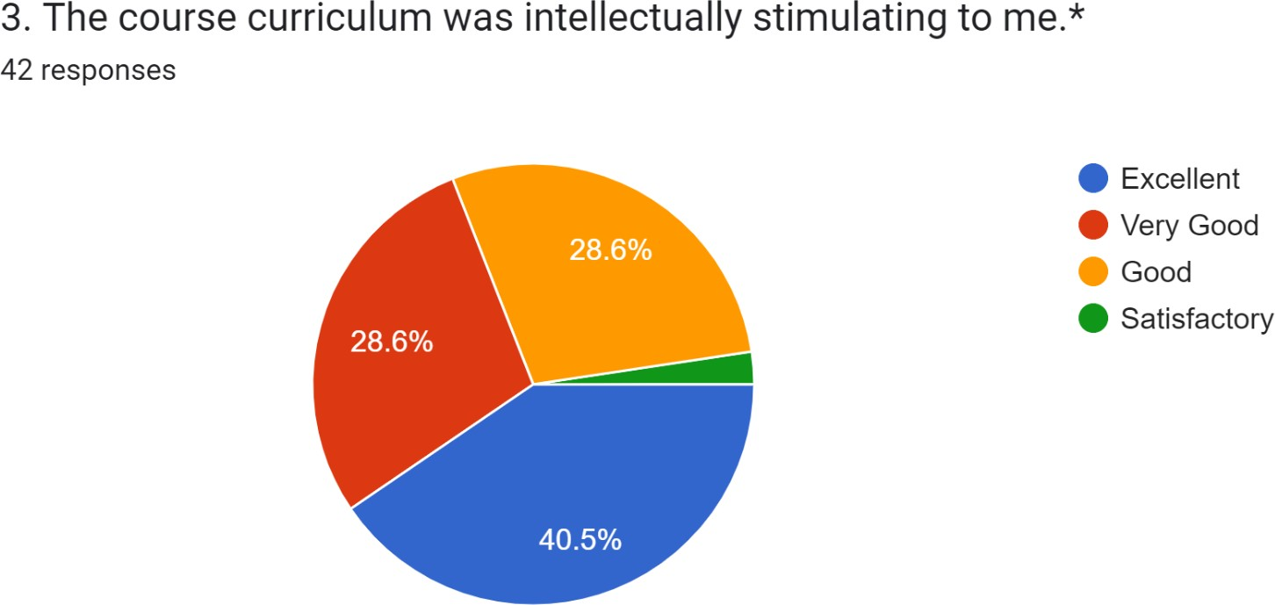

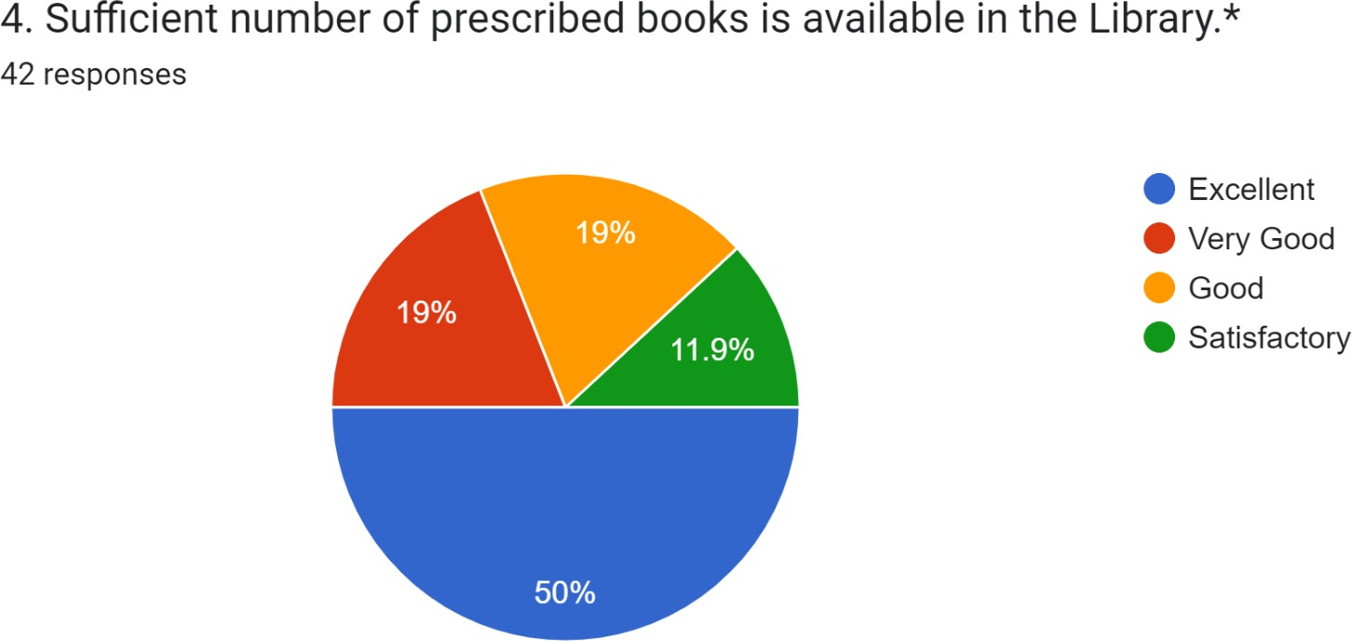

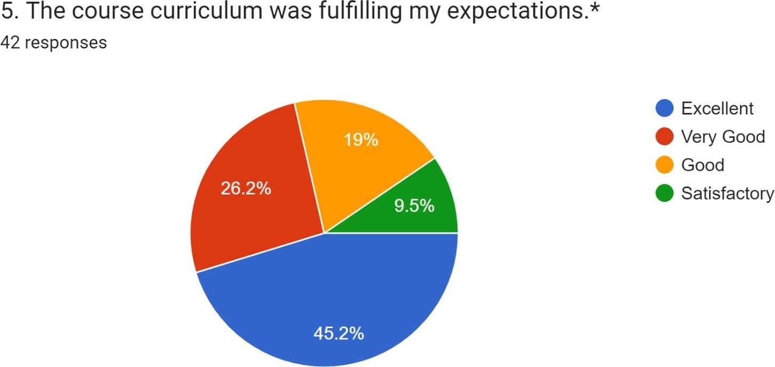

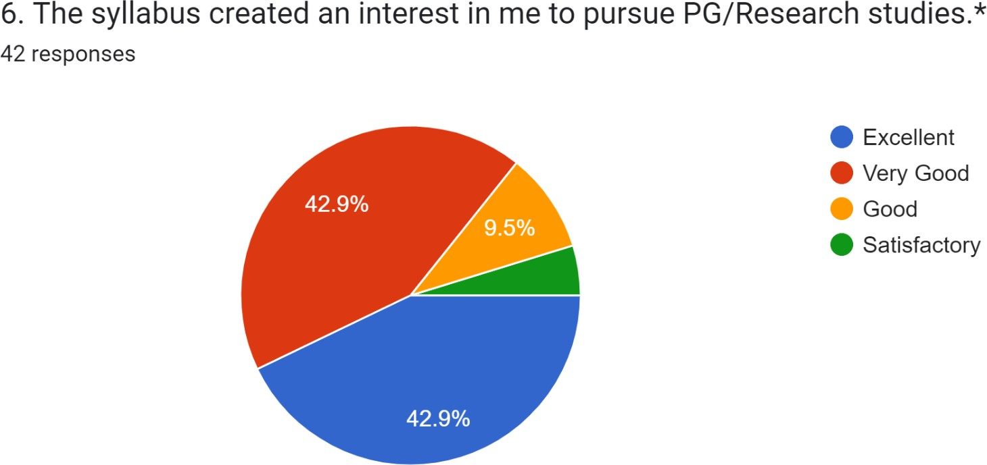

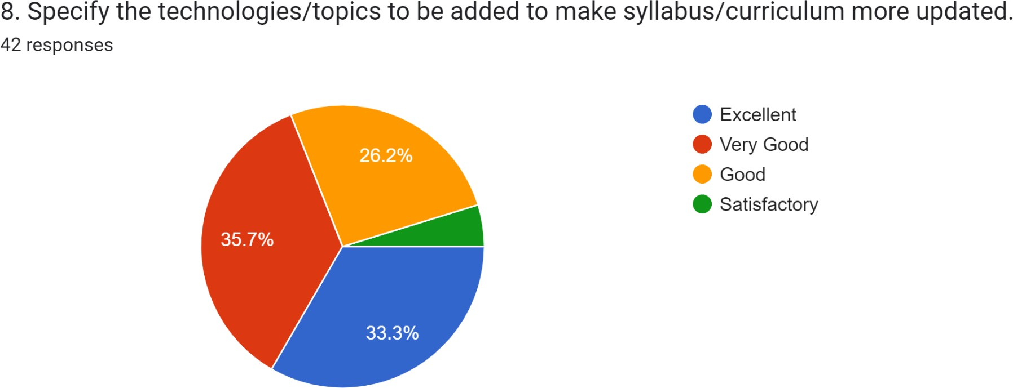
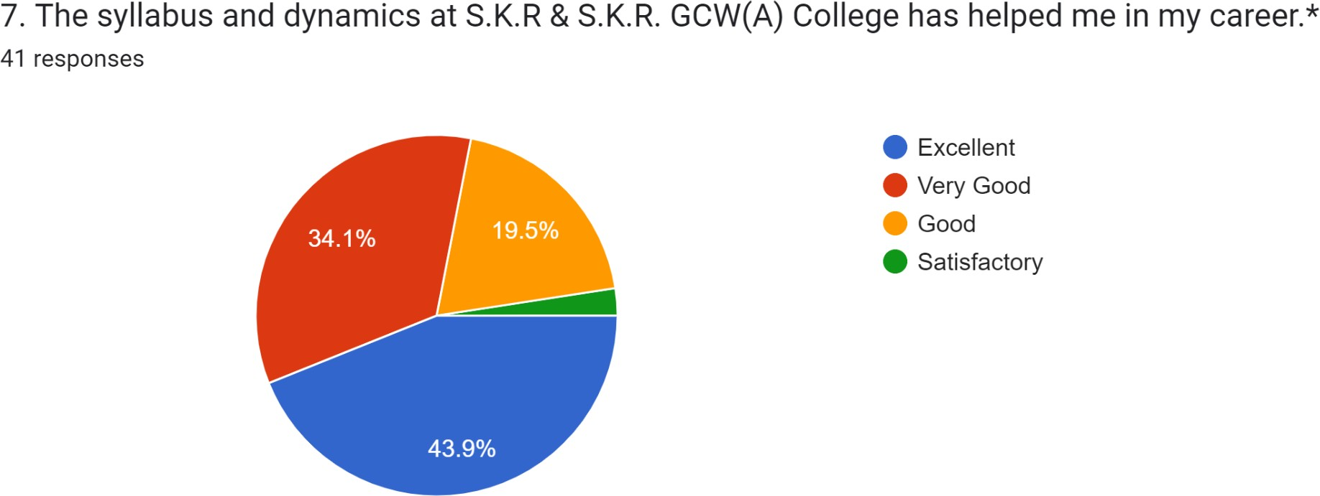

ACTION TAKEN REPORTS ON Alumni FEEDBACK ON CURRICULUM
Action Taken Report 2021-22
Most of the Alumni are of Excellent opinion on curriculum design and development. Very few expressed improvements over some questions. Based on these opinions the following action has been taken.

S.No | Areas on which students expressed dissatisfaction | Action Taken
1 | Ability to work in arduous /Challenging situation | These areas, on which Alumni expect improvement, have been considered and are conveyed during evaluation time to the BOS members.
2 | Resource and Time management skills
3 | Oral communication

Internal quality assurance cell
Feedback Analysis Report-2021-2022

Feedback Collection, and Analysis Report of 2021-22
4.Employer feedback Analysis: 19

Collection of Feedback
Online comments on the curriculum and associated topics have been gathered in IQAC at www.skrgdcwakdp.edu.in. For each group—students, teachers, alumni, and employer experts—separate feedback forms have been developed. This tab is available around-the-clock, and analysis is done for 2021-2022 .
4.Employer feedback Analysis: 19
. The feedback on curriculum from employer were obtained after the end of each academic
2021-22 session. six curriculum-related questions make up the format of the Alumni questionnaire. Students opinion on syllabus were measured in a four -point scale (1- Excellent-2- Very Good -3-Good-4- Satisfactory). 19 Employer from 19 UG programs and 2 PG programs provided feedback on the curriculum.

Internal quality assurance cell
Feedback Analysis Report-2021-2022

S.No | Description | Excellent | Very Good | Good | Satisfactory
1 | The syllabus makes the students competent | 57.9% | 42.1% | -- | --
2 | The syllabus promotes innovate | 57.9% | 42.1% | -- | --
3 | The syllabus effective to developing the entrepreneurial skills of the student | 57.9% | 42.1% | -- | --
4 | The syllabus enables to enchase the quality of the students in terms of presentations, aptitude, behavior, attitude, subject knowledge, technical and communication skills | 100% | -- | -- | --
5 | Course content has enough scope for development of analytical, logical technical and creative skills to the students | 73.7% | 26.3% | -- | --
6 | Awareness on the recent developments in the field is provided. | 42.1% | 47.4% | 10.5%

Internal quality assurance cell
Feedback Analysis Report-2021-2022

4.Employer feedback Analysis: 19

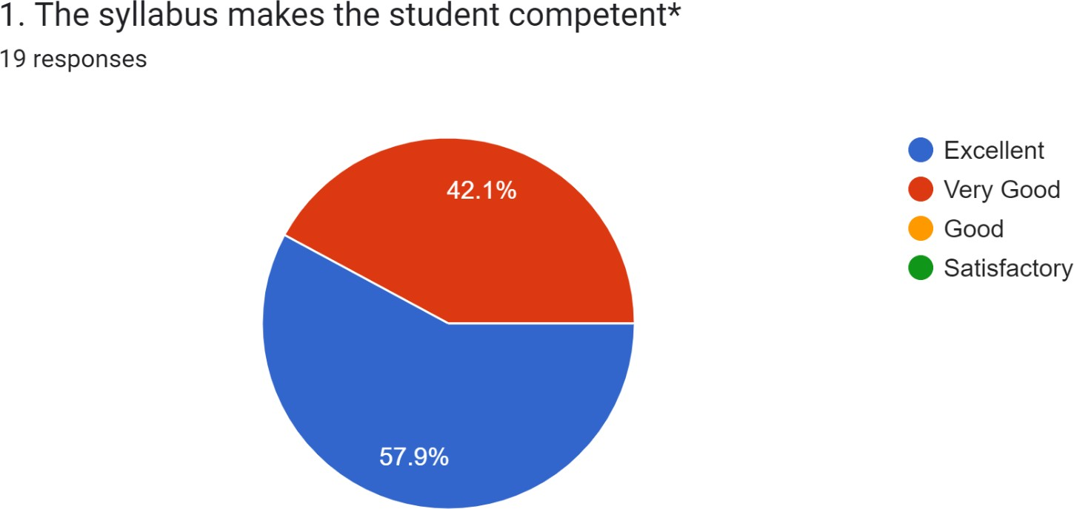

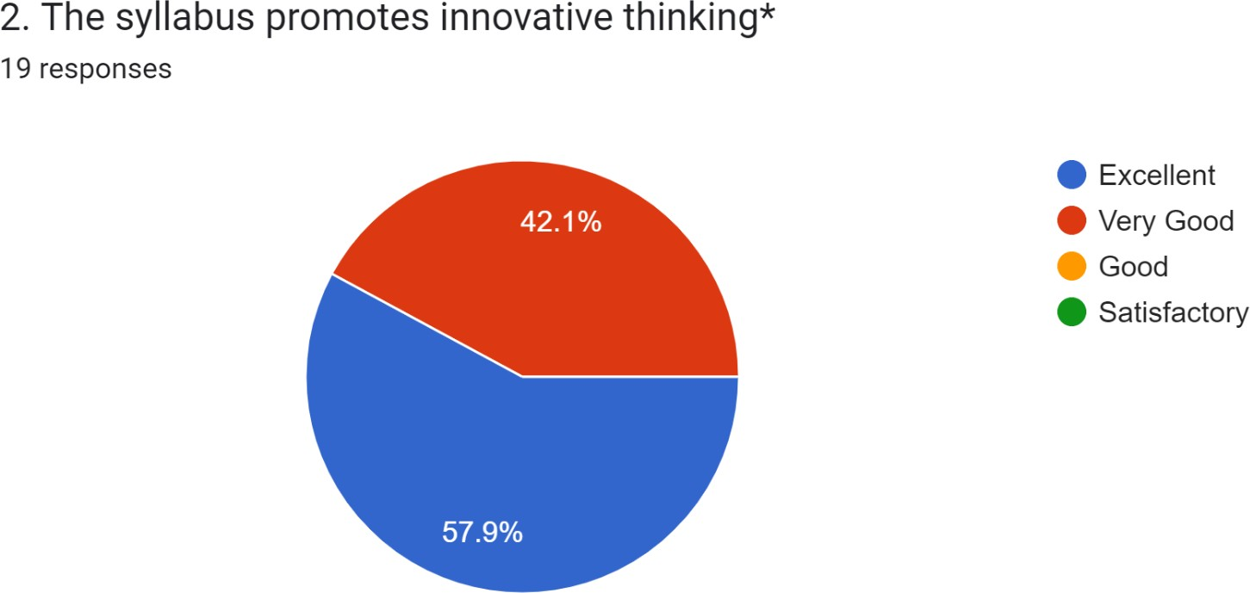

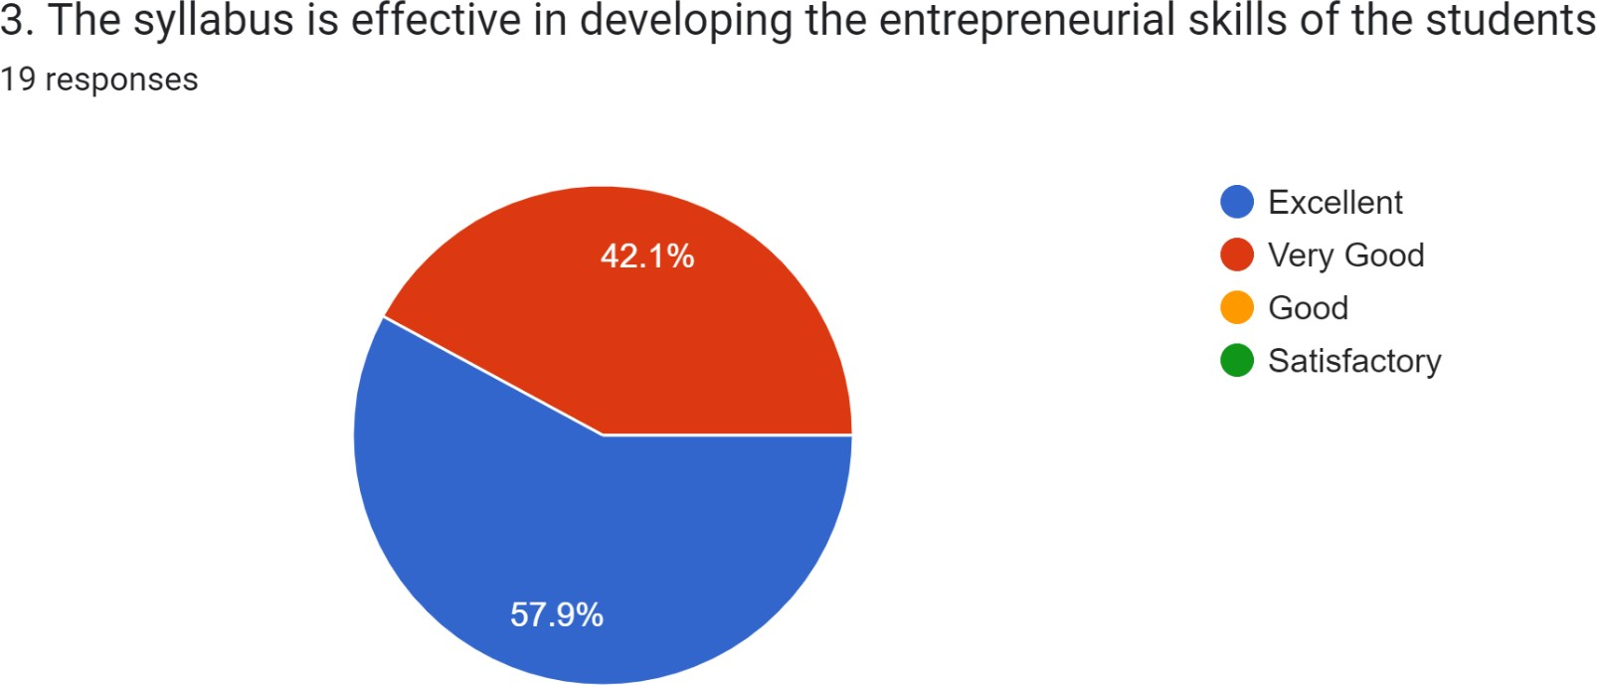
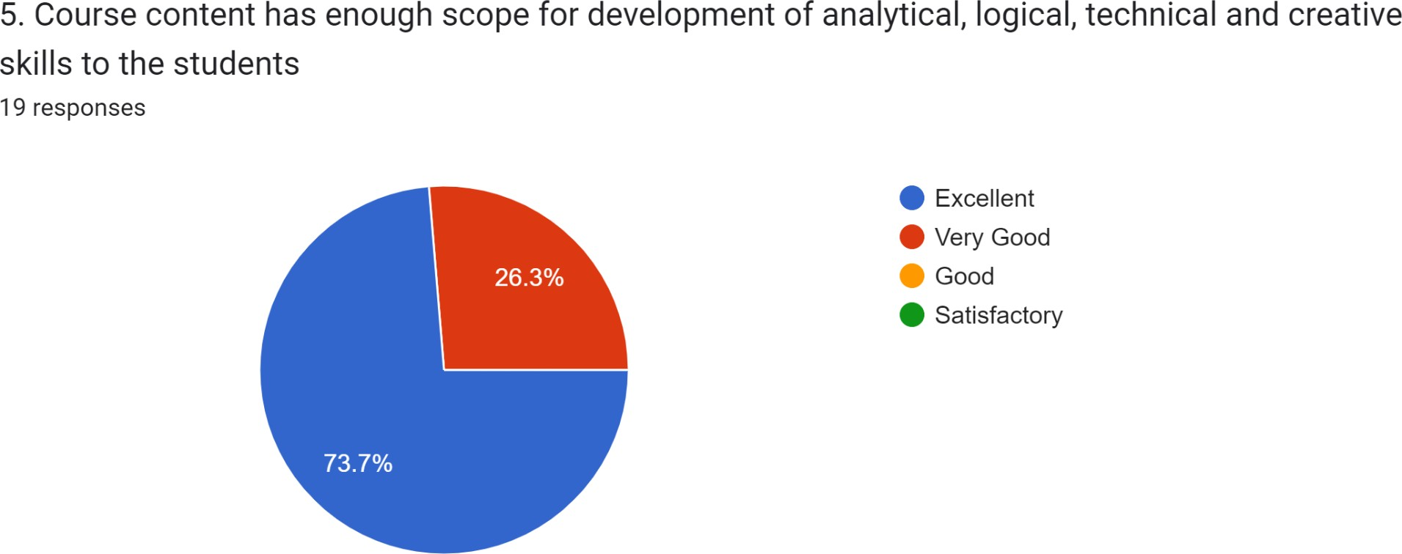

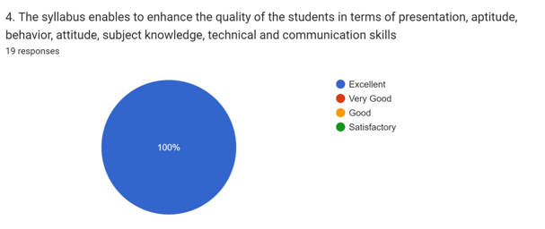

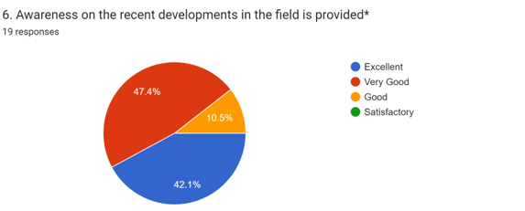

ACTION TAKEN REPORTS ON Employer’ FEEDBACK ON CURRICULUM
Action Taken Report 2021-22
All Most all the employer are of Excellent opinion on curriculum design and development. But the faculty has unanimously agreed that adding to or changing the syllabus must be done periodically. New Programmes Started 1.BA (HPU), 2021-22 and BBA will be stared 2022-2023.
2.Certificate Courses organized
3.Field trips, field projects (CSP) to be down
4. Through Compulsory internship provide the students.
5.Coaching for all competitive exam and PG entrance have provide every year
6.JKC Placement cell organized on campus job mela
7. Training programme in professional skills

